

Electron Devices Project:

Smart Table Lamp

By P.Vasudevan RA1511004010155

Abstract:

In this day and age we expect everything to be smart, fast and easily accessible and comfortable for us to use. We expect everything to understand our needs and desires and to work the way we want it to without much hassle. This project epitomizes how a humble thousand year old staple in every house the desk lamp can be made smart and be made a piece of tech that reflects the fast growth of wireless technology, connected devices and smart devices.

Description:

The Smart Table lamp is based on Bluetooth technology and Motion Detection using PIR sensors

The components we have used are:

1. Arduino microcontroller

2. 2-Channel Opt coupler Relay

## 3. HC-SR501 PIR Sensor

4. HC-05 Bluetooth

5. LM35 Temperature Sensor

6. Incandescent Bulb

7.16x2 LCD Display

8. Pushbutton

9. 10k ohm Pot

10. 1k Resistor

11. Jumpers and Breadboard

Motion Detection Mode:

**How It Works**



First let’s explain the working principle. The module actually consists of a Pyroelectric sensor which generates energy when exposed to heat.

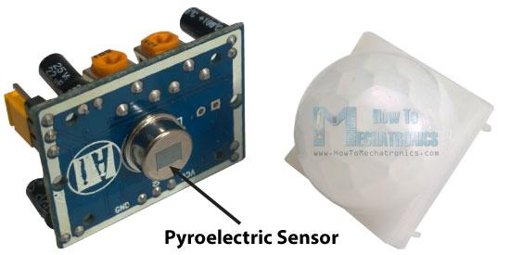

That means when a human or animal body will get in the range of the sensor it will detect a movement because the human or animal body emits heat energy in a form of infrared radiation. That’s where the name of the sensor comes from, a Passive Infra-Red sensor. And the term “passive” means that sensor is not using any energy for detecting purposes, it just works by detecting the energy given off by the other objects.

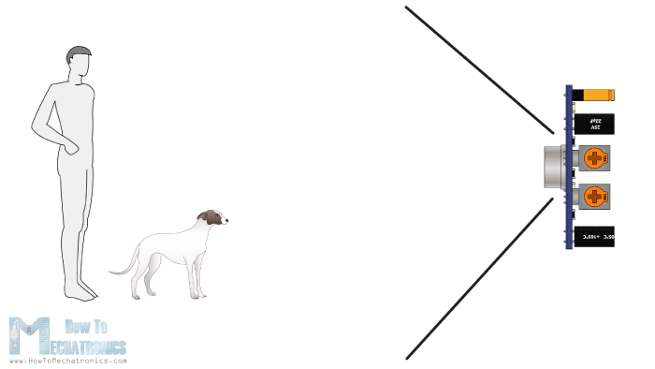

The module also consists a specially designed cover named Fresnel lens, which focuses the infrared signals onto the pyroelectric sensor.

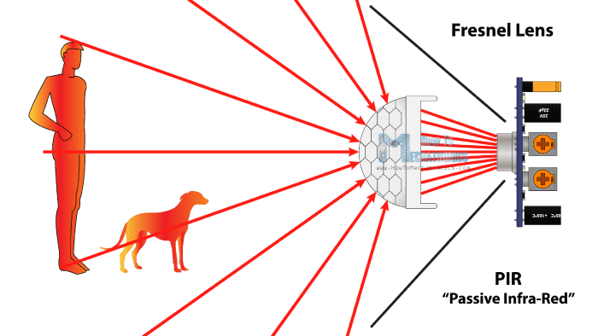

The module has just three pins, a Ground and a VCC for powering the module and an output pin which gives high logic level if an object is detected. Also it has two potentiometers. One for adjusting the sensitivity of the sensor and the other for adjusting the time the output signal stays high when object is detected. This time can be adjusted from 0.3 seconds up to 5 minutes.

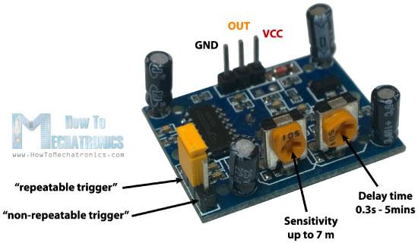

The module has three more pins with a jumper between two of them. These pins are for selecting the trigger modes. The first one is called “non-repeatable trigger” and works like this: when the sensor output is high and the delay time is over, the output will high to low level. The other mode called “repeatable trigger” will automatically change fro keep the output high all the time until the detected object is present in sensor’s range.

Relay Working:

**Overview**



We can control High Voltage electronic devices using relays. A Relay is actually a switch which is electrically operated by an electromagnet. The electromagnet is activated with a low voltage, for example 5 volts from a microcontroller and it pulls a contact to make or break a high voltage circuit.

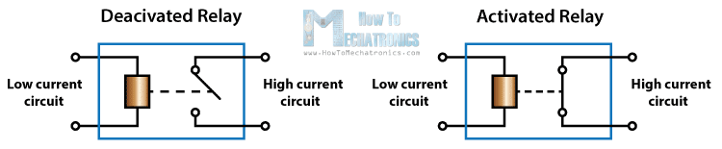

**Circuit Schematic**



For better understanding let’s see the circuit schematics of the relay module in this configuration. So we can see that the 5 volts from our microcontroller connected to the Vcc pin for activating the relay through the Optocoupler IC are also connected to the JDVcc pin which powers the electromagnet of the relay.

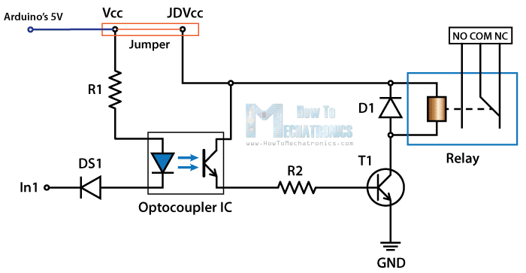

Bluetooth Mode:

The Arduino Uno uses Universal Synchronous Asynchronous Receiver and Transmitter (USART) for communication between our computer and any other serial device. It uses a baud rate of 9600. So to access the wireless portion of our object we use the HC-05 Bluetooth Module which will hook up our Arduino’s serial USART port to the Bluetooth communication in our phone or our laptop using an apps called BlueTerm and TeraTerm respectively.

Code:

#include <LiquidCrystal.h>

LiquidCrystal lcd(2, 3, 4, 5, 6, 7);

char data;

char modedata;

int pir=8;

int relay=9;

int value=A0;

int temp=0;

float volts=0.0;

void setup() {

pinMode(relay,OUTPUT);

pinMode(pir,INPUT);

lcd.begin(16,2);

Serial.begin(9600);

}

void loop() {

lcd.setCursor(0,0);

lcd.print("Bluetooth Mode");

value=analogRead(A0); //read from A0

volts=(value/1024.0)*5.0; //conversion to volts

temp= volts*100.0; //conversion to temp Celsius

//display temp no lcd

lcd.setCursor(0,1);

lcd.print("TEMP= ");

lcd.print(temp);

lcd.print(" C");

modedata = Serial.read(); //Read byte of data

//Turn Relay on

if (modedata == '1')

{

digitalWrite(relay,LOW);

Serial.println("Lamp ON");

}

//Turn Lamp off

else if (modedata == '0')

{

digitalWrite(relay, HIGH);

Serial.println("Lamp OFF");

}

else if (modedata == '5')

{lcd.clear();

lcd.print("Motion Detection Mode");

value=analogRead(A0); //read from A0

volts=(value/1024.0)*5.0; //conversion to volts

temp= volts*100.0; //conversion to temp Celsius

//display temp no lcd

lcd.setCursor(0,1);

lcd.print("TEMP= ");

lcd.print(temp);

lcd.print(" C");

while(modedata == '5')

{ int sensorValue = digitalRead(pir);

if (sensorValue == 0)

{

digitalWrite(relay,HIGH);

}

else if (sensorValue == 1) {

digitalWrite(relay, LOW); // The Relay Input works Inversly

delay(500);

}

if(Serial.available()>0)

{

Serial.println("exited");

lcd.clear();

break;

}

}

}

}

Applications:

There are various applications for the technology used in this project even though this is a product specific project i.e a smart lamp there are various ways to expand the project for example using an esp8266 Wi-Fi module to connect the lamp to the cloud and create an internet on things connected lamp which can be controlled from anywhere from the world.

References:

1.howtomechatronics.com

2.arduino.cc

3.Exploring Arduino by Jeremy Blum